**DAILY ONLINE ACTIVITIES SUMMARY**

|  |  |  |  |  |  |  |  |
| --- | --- | --- | --- | --- | --- | --- | --- |
| **Date:** | **10/06/2020** | | | | **Name:** | **Syed Rabeya Aamir** | |
| **Sem & Sec** | **8th B** | | | | **USN:** | **4AL16CS112** | |
| Online Test Summary | | | | | | | |
| **Subject** | | **__** | | | | | |
| **Max. Marks** | | **__** | | **Score** | | **__** | |
| Certification Course Summary | | | | | | | |
| **Course** | **Aws cloud practitioner Essential.** | | | | | | |
| **Certificate Provider** | | | **Aws** | **Duration** | | | **6 hrs** |
| Coding Challenges | | | | | | | |
| **Problem Statement:**  **1) Write a Python program to find a list of uncommon words.** | | | | | | | |
| **Status: Solved** | | | | | | | |
| **Uploaded the report in Github** | | | | **YES** | | | |
| **If yes Repository name** | | | | **rabeya** | | | |
| **Uploaded the report in slack** | | | | **YES** | | | |

**Certification Course Details:**

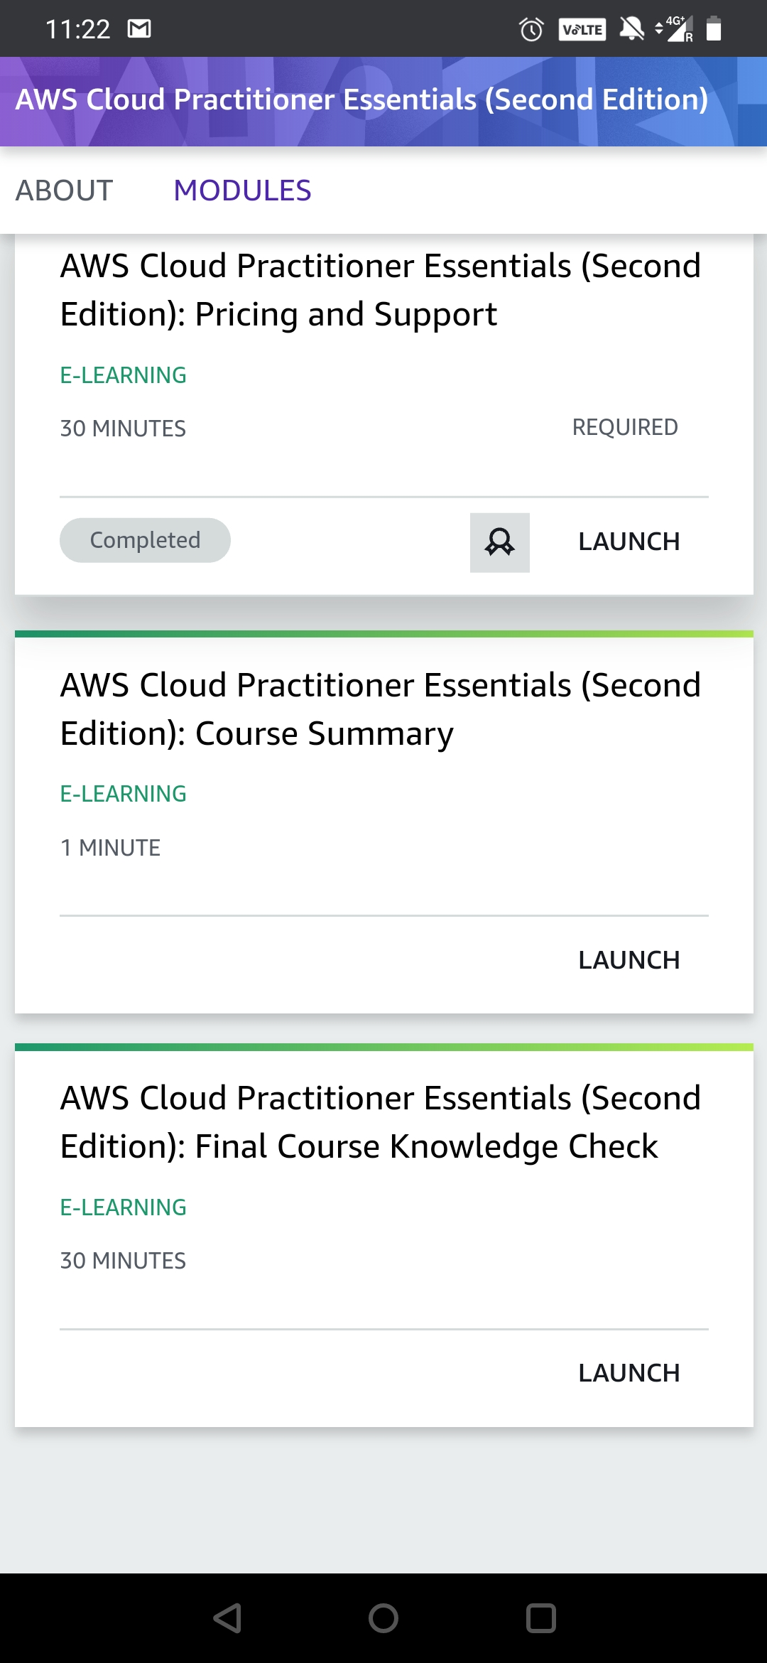

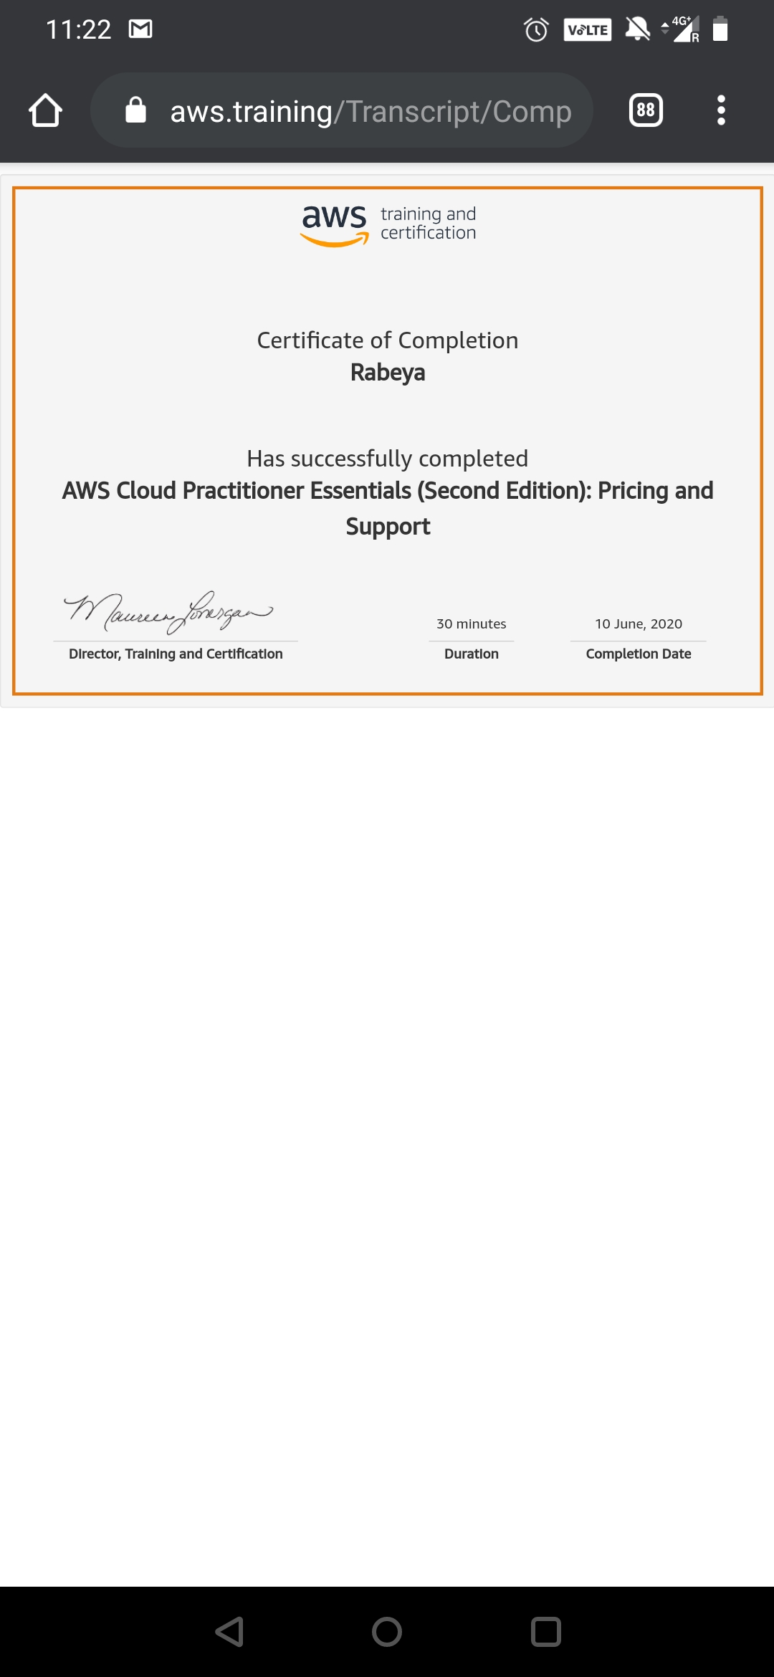

# CODE:

Program no:1

## Python program to find a list of uncommon words

def UncommonWords(string1, string2):

count = {}

for word in string1.split():

count[word] = count.get(word, 0) + 1

print(count)

for word in string2.split():

count[word] = count.get(word, 0) + 1

print(count)

return [word for word in count if count[word] == 1]

string1 = "Hello World"

string2 = "Hello Everyone"

print(UncommonWords(string1, string2))